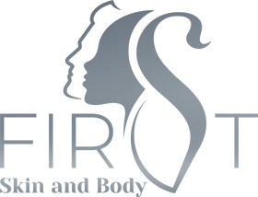

**FACE**

Top Lip $49

Chin $49

Top Lip + Chin $69

Nose $49

Eyebrows $49

Ears $49

Full Face $199

Half Face $129

**ARMS**

Arms Full $180

Arms Half $130

Underarms $69

**LEGS**

Full Leg $199

Half Leg $129

**BODY**

Chest $129

Back $229

Half Back $129

Shoulders $129

Stomach $149

Neck $129

Chest + Stomach $199

Upper Body (Chest + Back) $299

**OTHER**

Bikini/Manscape $69

Brazilian $129

Buttocks $129

Nipples $49

Midline $49

Toes $49

Hands $49

Bikini & Underarms $129

Ground Floor, Next Generation Club, War Memorial Drive, North Adelaide, 5006  
Phone: 08 8410-7877  
www.firstskinandbody.com.au

Computer Icons Logo, facebook, logo, logos, follow Us On Instagram png ...